2013 ACE Critique and Awards Program
NMSU Media Productions — Jeanne Gleason

Game Over Gopher  Class 38:  Interactive Media Program | 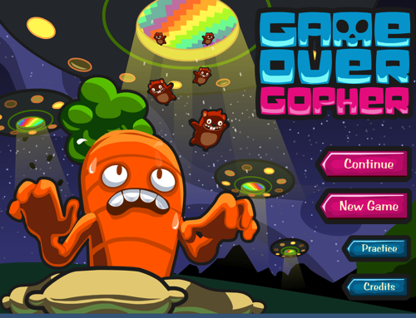
To play the Game Over Gopher game, visit mathsnacks.com/GameOverGopher.html. To unlock all levels for evaluation, hold down the shift and c buttons on your keyboard when in the level select screen (the screen with all the little TVs on it). (Though we recommend playing at least the first level all the way through, or – better yet – watch a mid-school student play!)
Overview:
Game Over Gopher is part of NMSU’s Math Snacks initiative funded by the National Science Foundation. The design team applied the Learning Games Design Model to the concept of placing coordinate pairs on a plane. Game designers worked hard to make sure that the game didn’t simply provide practice in doing so, but supported learners who had not previously encountered the concept in building their own knowledge through gameplay.
Purpose (goals, objectives, need):
Game Over Gopher addresses objectives from the National Common Core mathematics standards, as well as key gaps in mid-school students understanding as reflected through project research. Math Snacks are games, interactive modules and short animations that help learners better understand the concepts behind mathematics content. They are not designed to replace instruction, but to supplement it by making math more accessible. Key concepts are conveyed in a creative, visual, and applied ways.
Team researchers analyzed standardized mathematics test results from over 400 teachers and 24,000 students, identifying the gaps in learning. They then observed classroom instruction and interviewed students and teachers to answer why commonly missed items were misunderstood. Mathematicians, math educators and technology experts worked together to identify classrooms needs, correlate identified gaps with new National Core Standards, and establish Math Snacks Learning Objectives. These objectives led to all Math Snacks games, including Game Over Gopher.
Audience:
While this game is designed for middle school, it has been used successfully with grades 3–8.
Marketing/promotion:
Currently in research phase, use of Game Over Gopher in randomized control trials has begun. At this time, the game is being used by teachers and children engaged in research trials and by those who have been exposed to the product through presentations, articles in journals, during summer teacher training programs, and through online curriculum portals like Edmodo.com. In anticipation of widespread release of the tools in 2014, NMSU is developing a marketing and promotion plan through NMSU’s Math Snacks outreach initiative, supported by a full-time NMSU staff member. The availability of many of these Math Snacks on the Internet, iPhone and iPad makes it possible for students to enjoy Math Snacks games and animations during non-school time as well as in class. The sustainability and commercialization of the products is also being considered, building on current Math Snacks distribution partnerships with BrainPop, the National Council of Teachers of Mathematics (NCTM), and a successfully funded NSF I-Corp proposal to investigate commercialization.
Role of each entrant for the project:
All work, including animation, programming and instructional design, was produced in NMSU’s Media Productions studios. The team for Game Over Gopher is listed in credits. The overall team includes animators, artists, programmers, designers, content specialists, writers and editors, as well as collaborators from NMSU’s College of Education. All have contributed to the game design process.
Extent to which project met goals and objectives:
Each game is pilot tested throughout development. Beginning in the fall of 2012, the Math Snacks team began initial controlled evaluated using random trials in school and after-school settings. The results of this research have not yet been analyzed, but anecdotal reports from teachers and the pilot testing trials suggest that Game Over Gopher is effective at teaching key concepts. Throughout the extensive user testing, the game was played by 20 different groups of kids, yielding suggestions and resulting in changes to gameplay and character design. The character design is frequently mentioned as one of the best aspects of the game. In fall, 2012, an external quality assurance committee reviewed the game, commenting extensively on the quality of the graphics.
How diversity was incorporated into entry:
New Mexico has a Hispanic-majority public school student body populations and has long been considered a bellwether for future student body characteristics in the U.S. Math Snacks has a proven track record of creating innovative products for all learners, with a design approach that involves underrepresented students throughout the design, development and testing phases of the products. Products have been tested extensively with diverse students and are reviewed by independent quality assurance panels, with specific attention paid to accessibility by diverse audiences and cultural sensitivity.
Other information:
All Math Snacks products are aligned with the Common Core State Standards for Mathematics (CCSSM) and address the CCSSM Mathematical Practices when used as recommended. Characters and graphics have been used across media.

